Create Project and initialize Git Repository
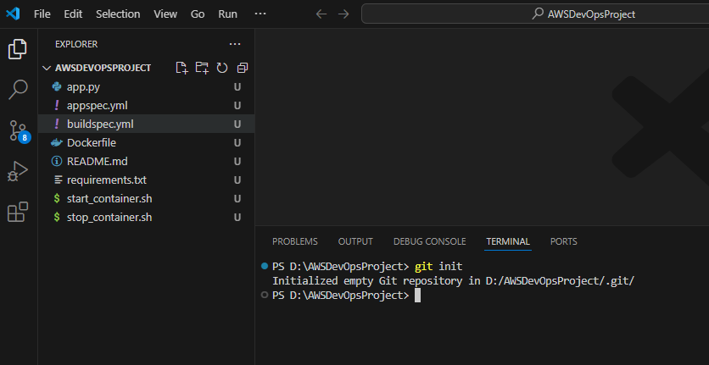
Commit code and push to Github repository created for this project
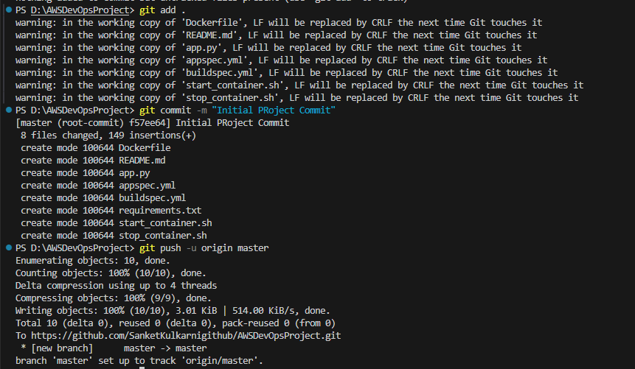

Github portal after code pushed from local repository
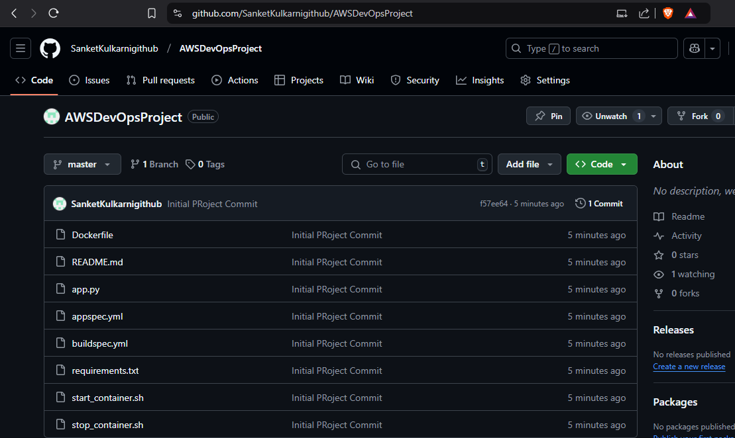
Go to AWS Portal -> Search CodeBuild -> Click on Create build project -> Enter Project Name -> Select Github as source 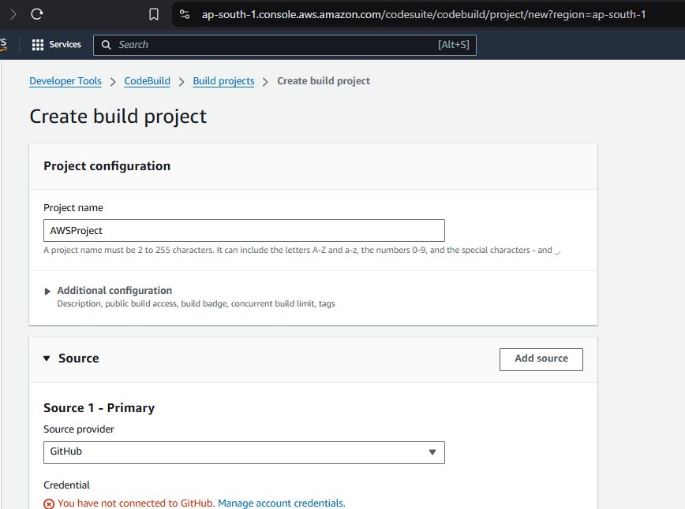
Manage account credentials of Github if not done already
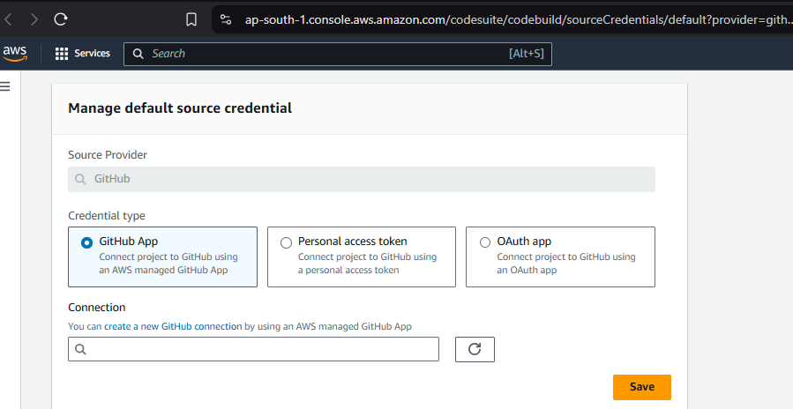
Create a new Github connection if one already not exist as shown below -> Click on Connect to GitHub
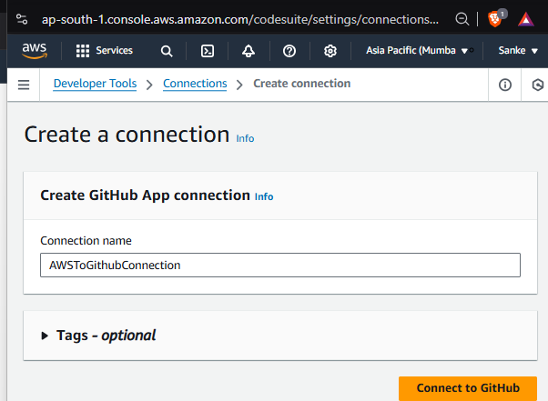

Click on Authorize AWS Connector for GitHub
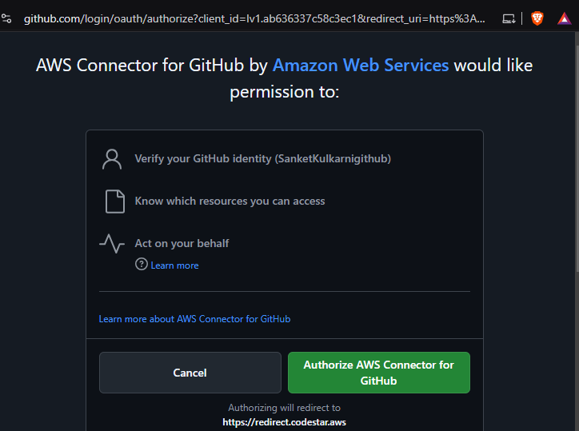
After authorization below page will open -> Click on Connect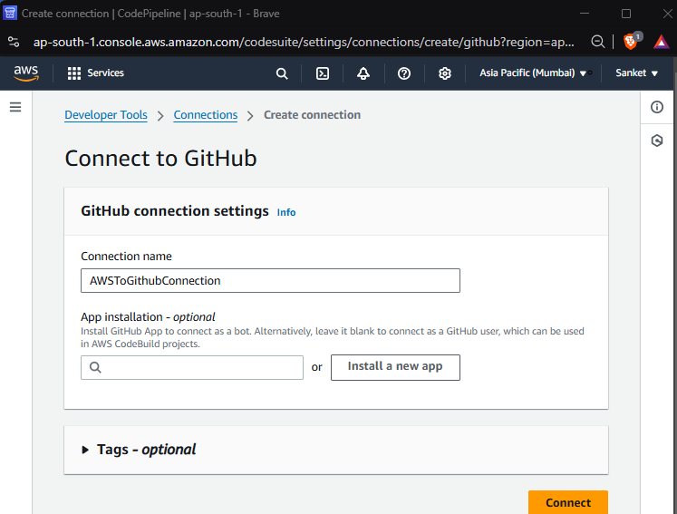
Go to Earlier page below -> Select the connection (which we created) -> Click on Save
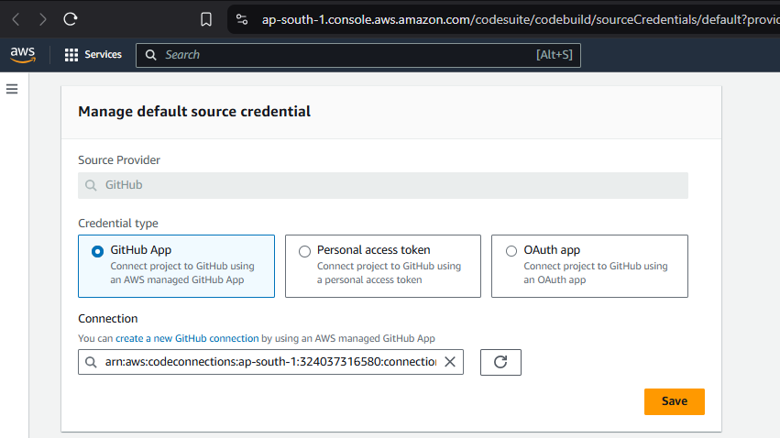
Not this is showing as Account is Connected to GitHub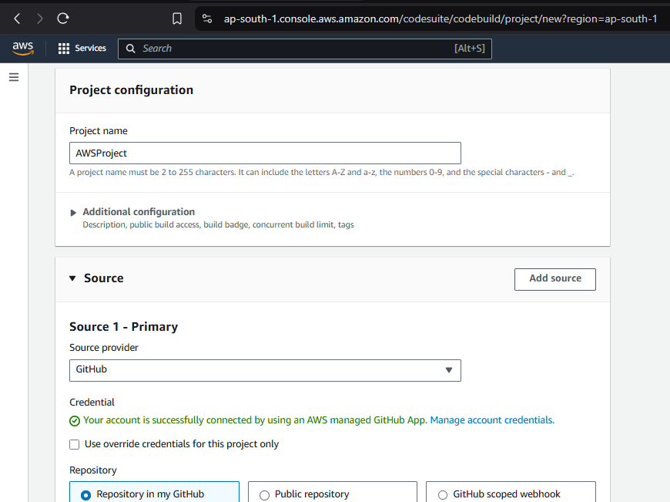
Enter the repository URL now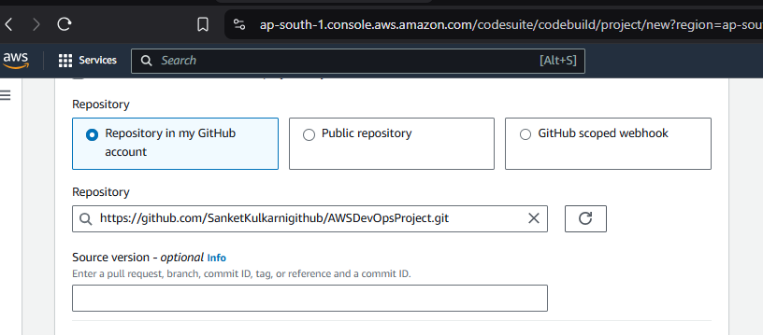

In Environment Section of same Page select values as below
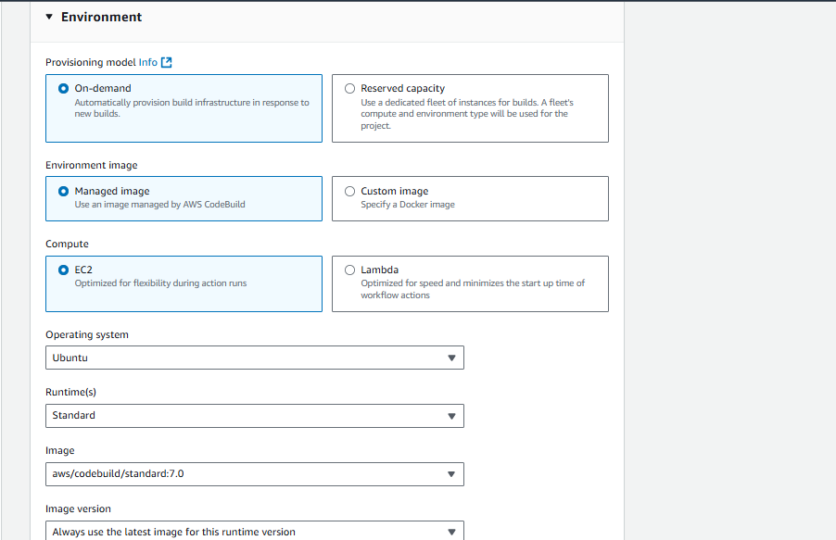
Select IAM Role to be used by CodeBuild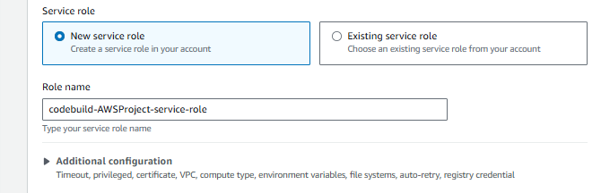
In Build Spec Section – Select Insert build commands -> Write the commands as shown below Need to modify later
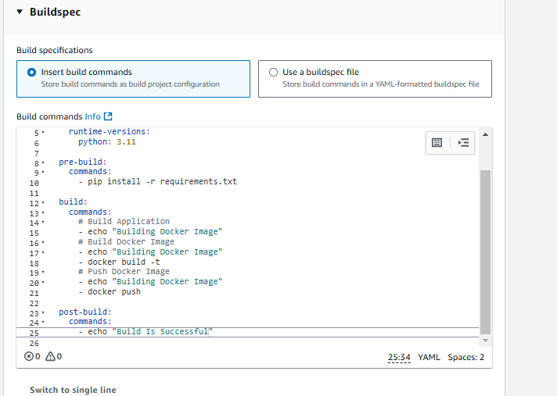
Artifact
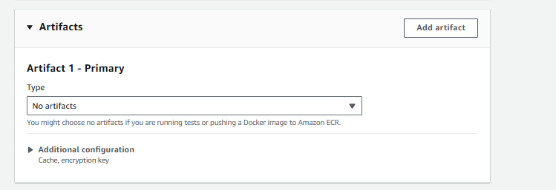

Create Build Project
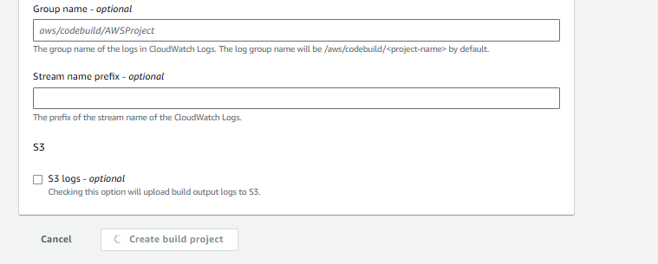
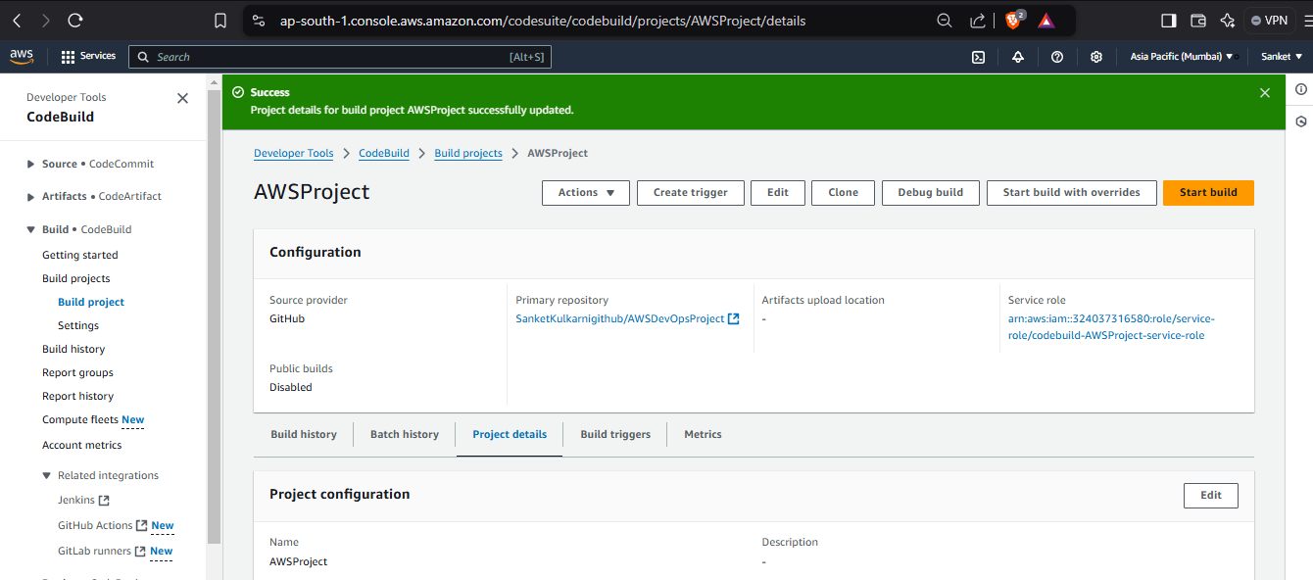

Open AWS Systems Manager -> Left hand side, select Parameter Store under Application Tools
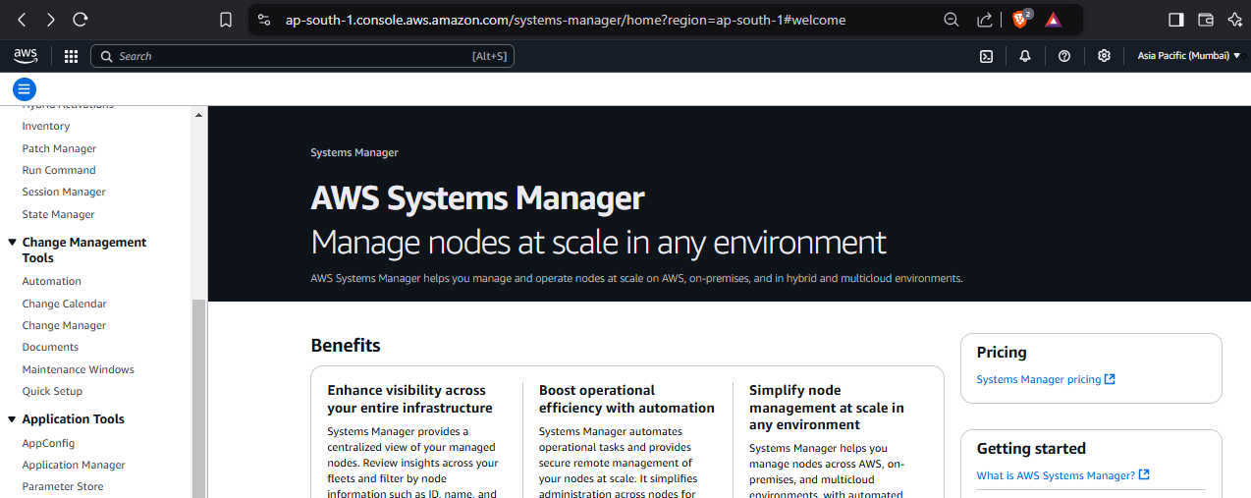

Parameter Store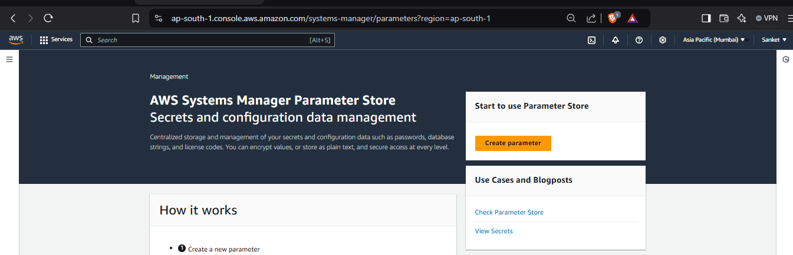
Click on Create Parameter ->Enter Name, Description, Tier, Type, Valie as shown and click on Create Parameter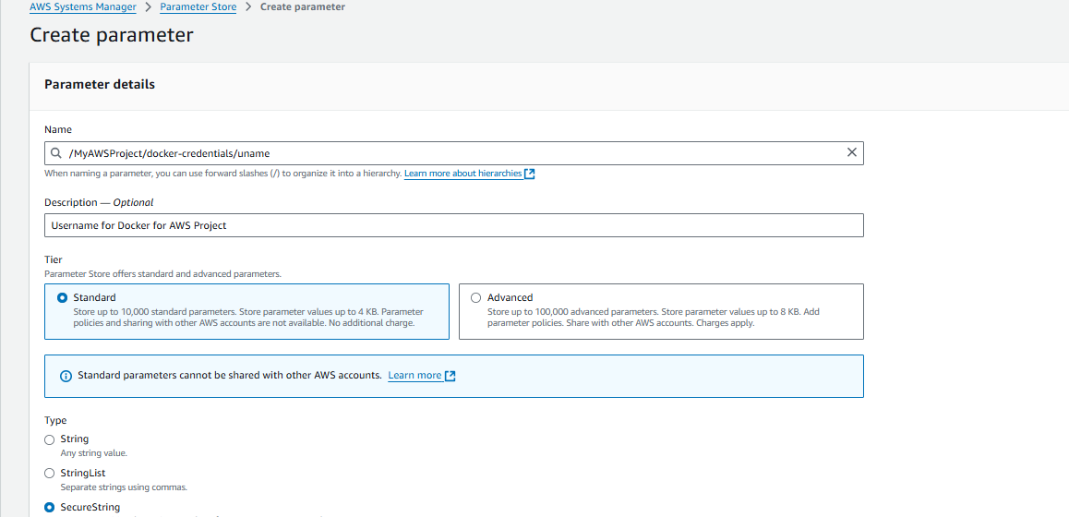
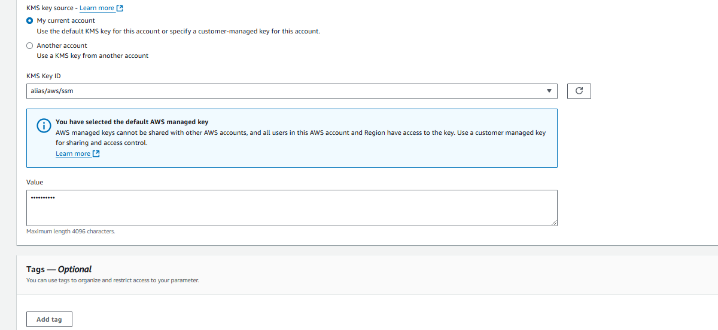
Same way, create for Password and Docker URL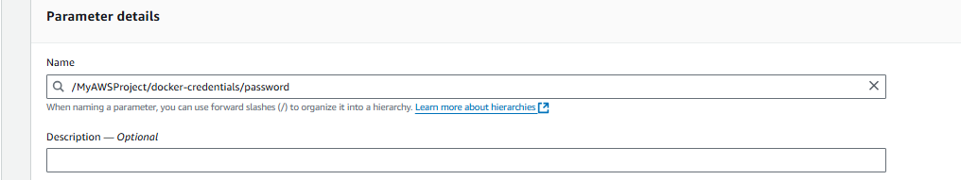
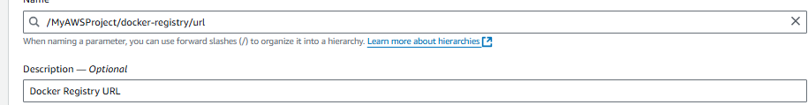
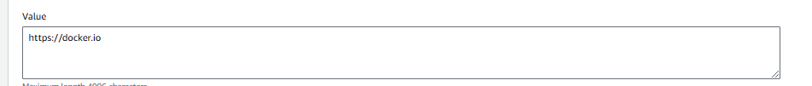
Search IAM Service -> On Right Side -> Access Management -> Click on Roles -> and Search and click our role (created earlier)
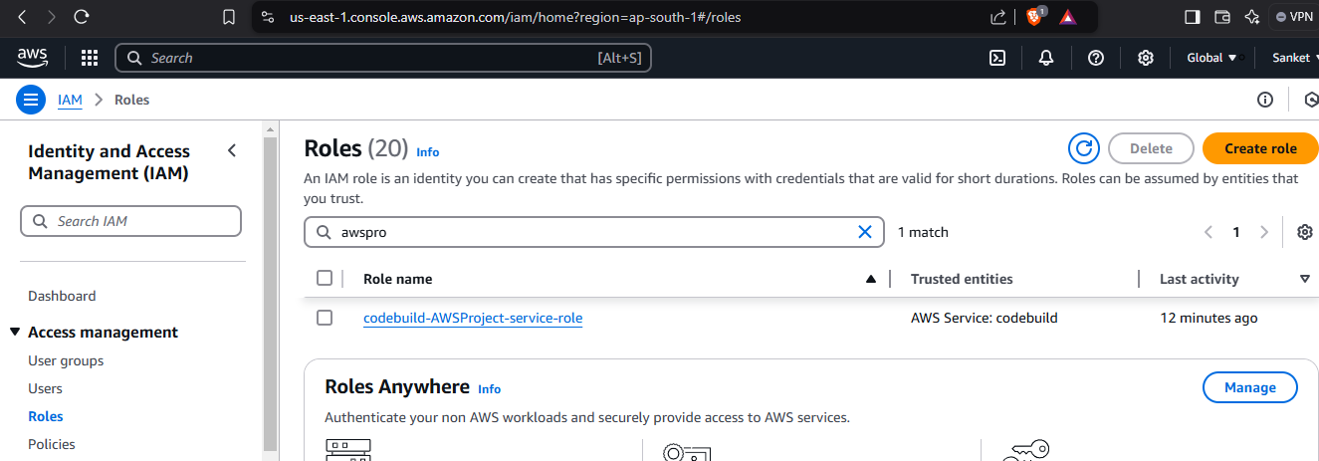
Click on Add Permissions -> Attach Policies
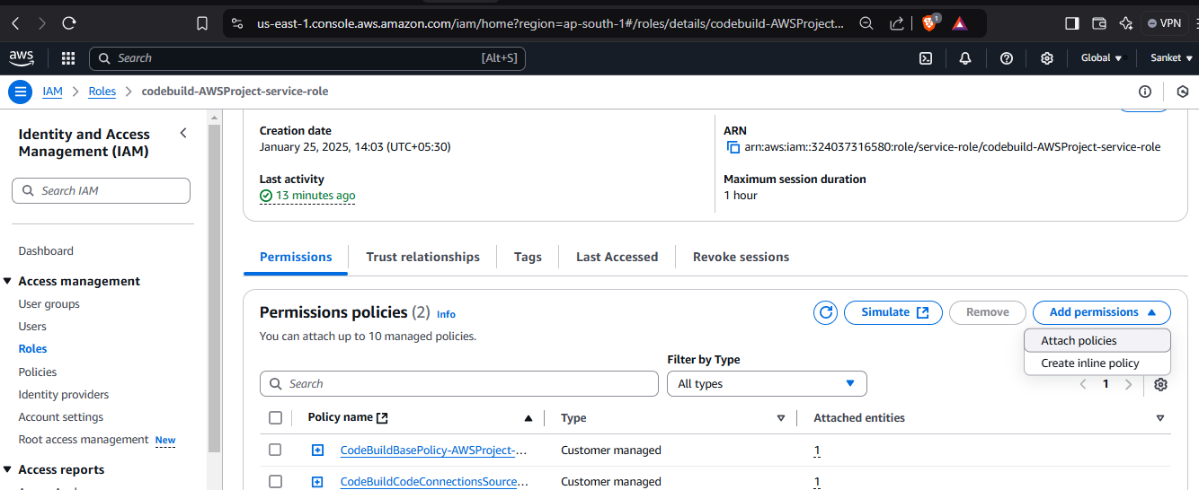
Search ‘ssm’ in policy (policy for system manager) -> Select the Full access and click on Grant Permission
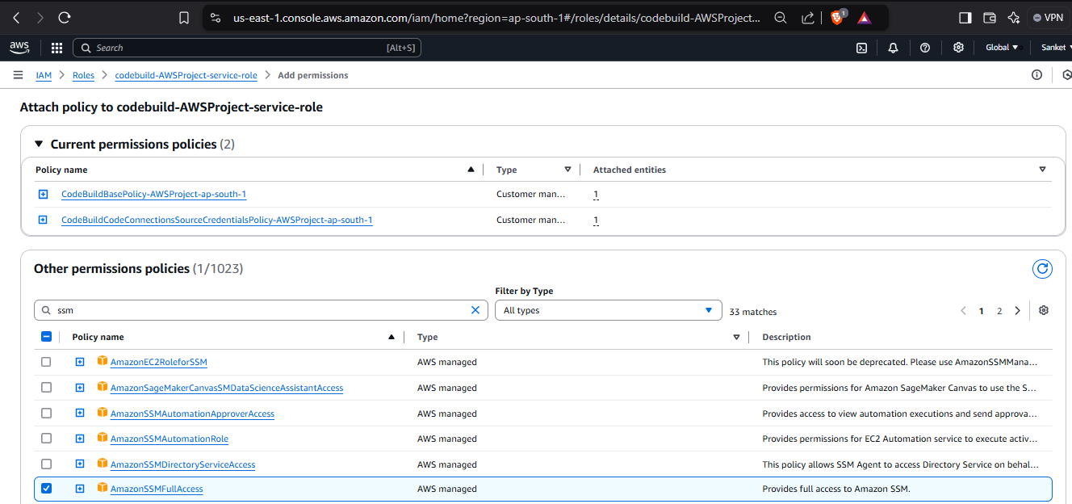
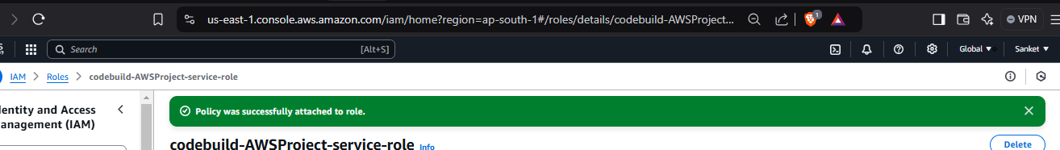
Go to our CodeBuild created earlier and click on Start Build
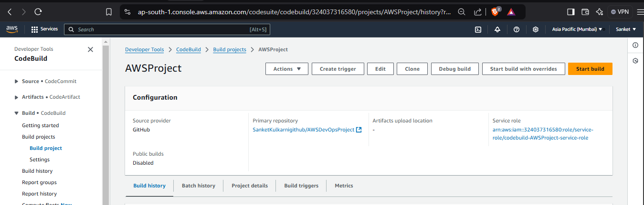

Search CodePipeline from Home page -> Click on Create Pipeline
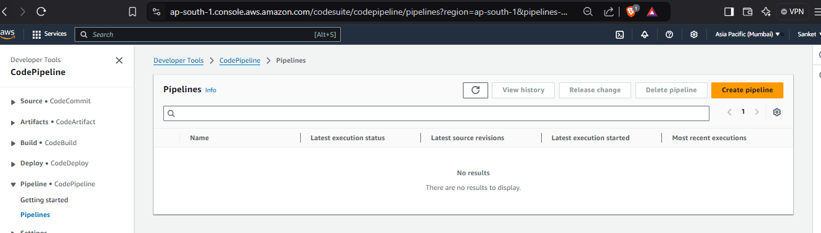
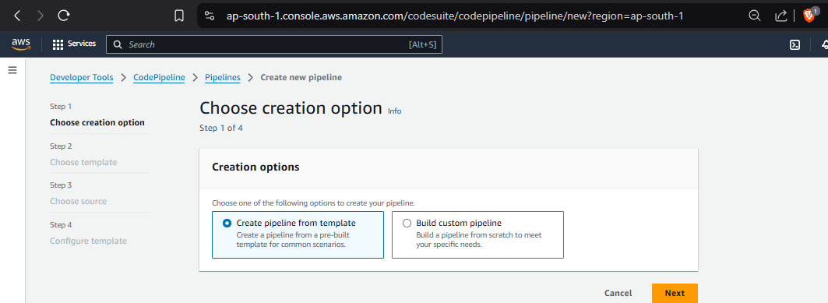
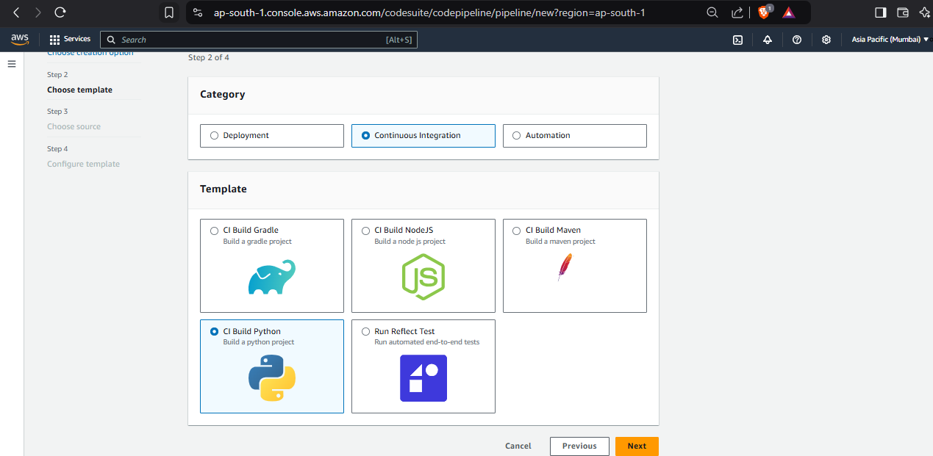

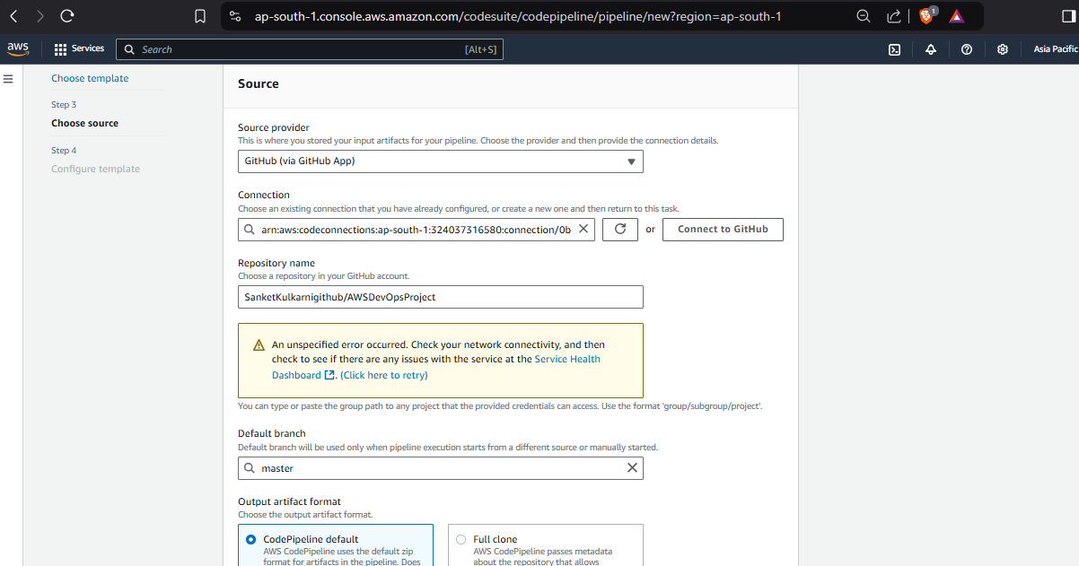

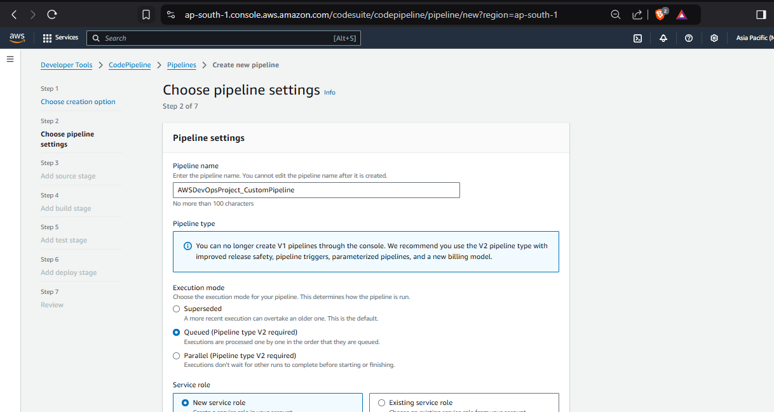
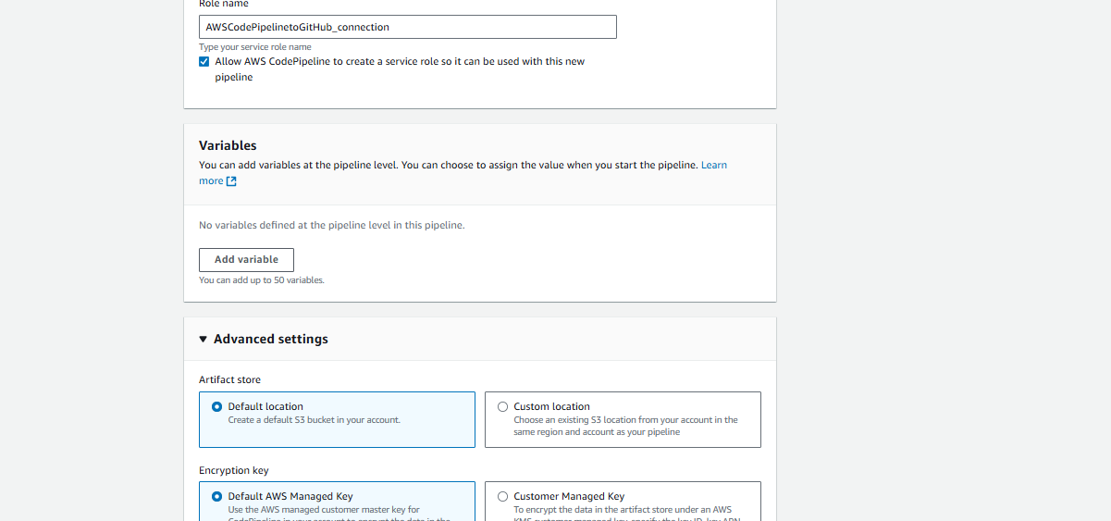
Source Stage ->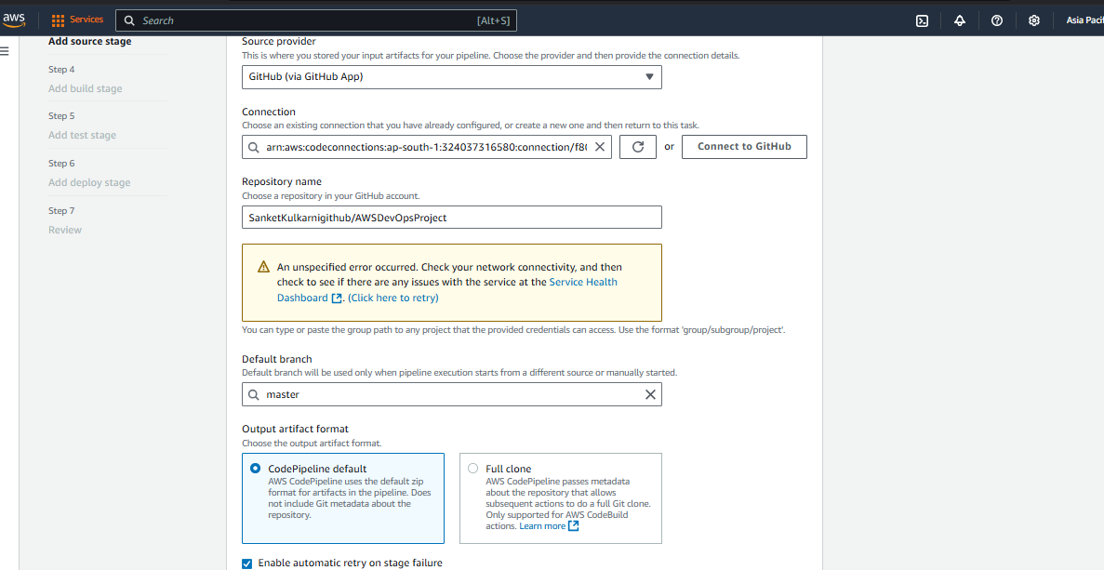

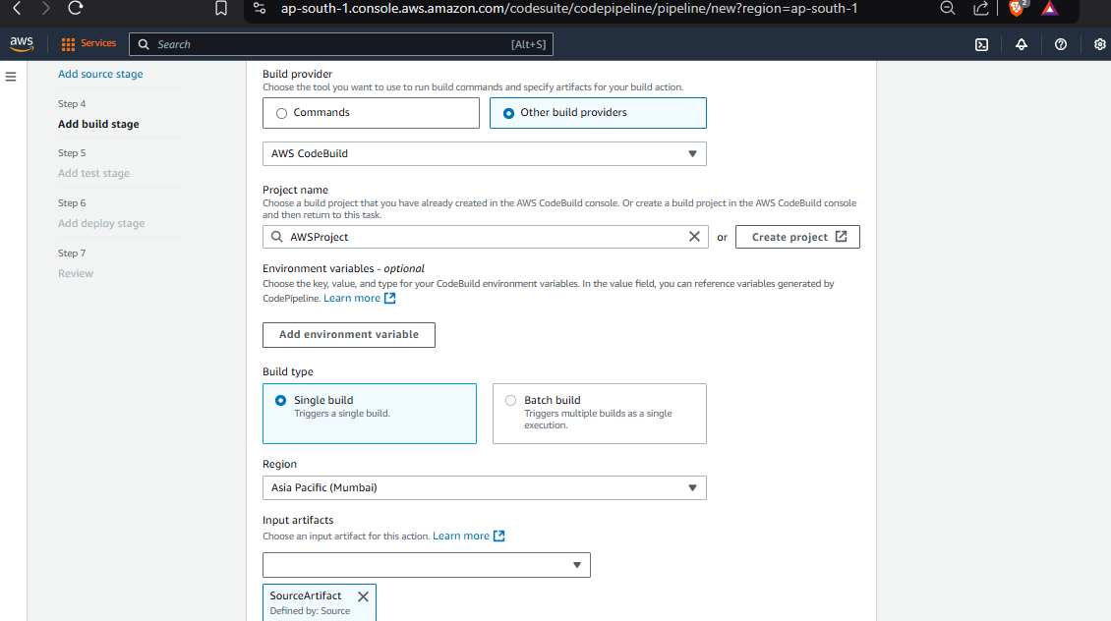
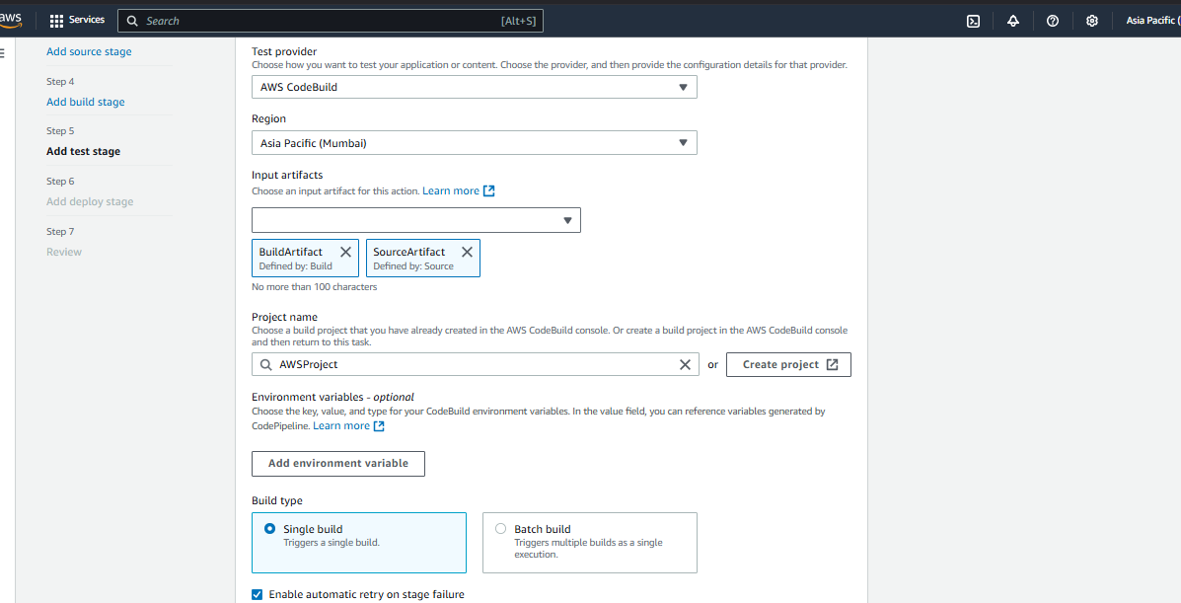

Execute build -> Build is successful
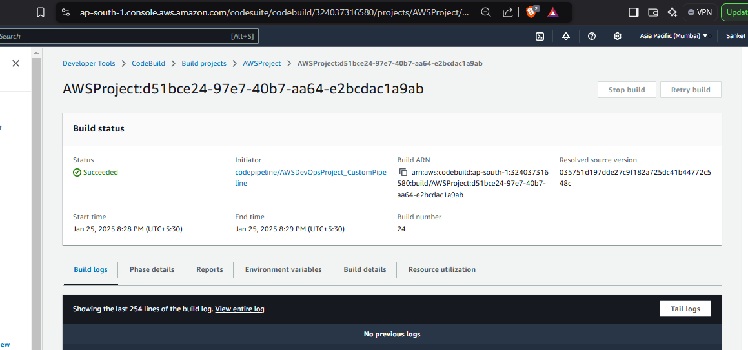

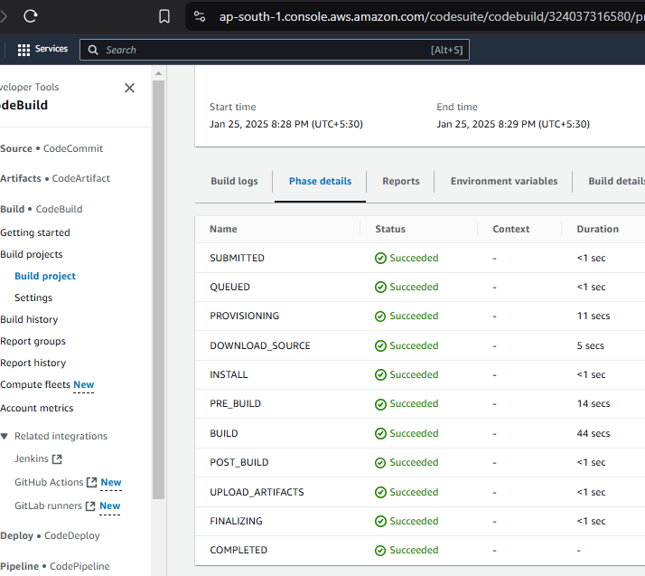
Install AWS CLI – Run command in CMD and a popo up will come -> Click on Install
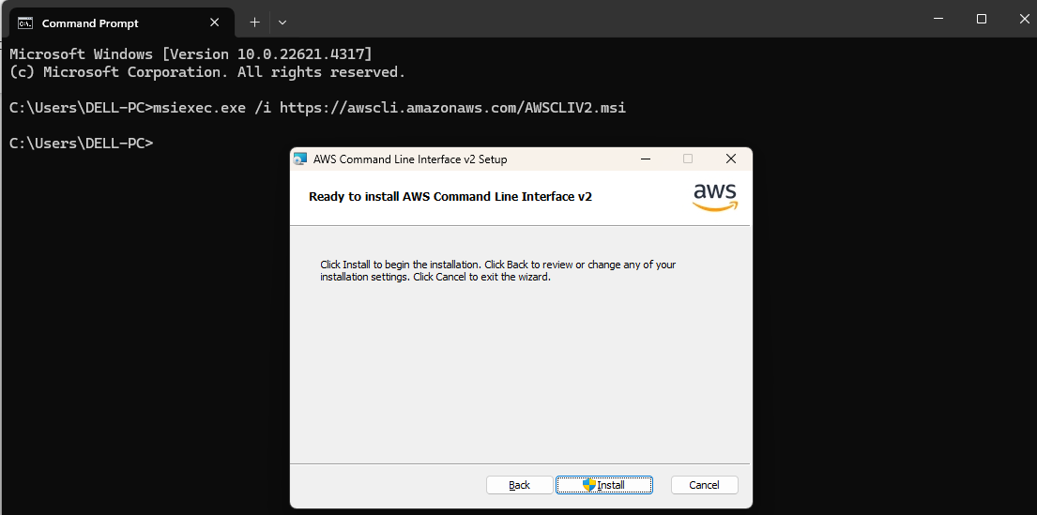
Close CMD and open again to check the installation is successful or not version
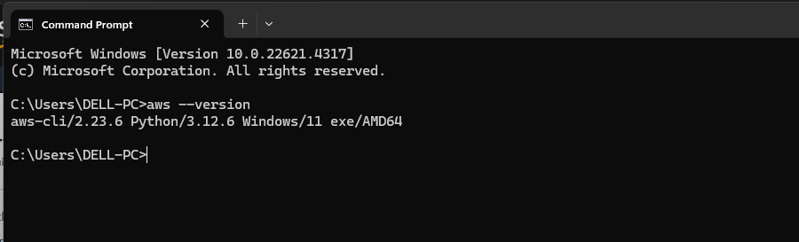

Terraform Installation is not working on desktop. So, lets create VM and install AWS CLI and Terraform there
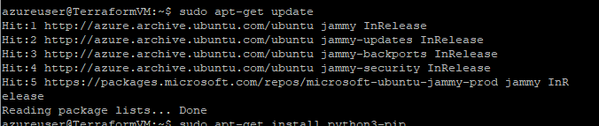
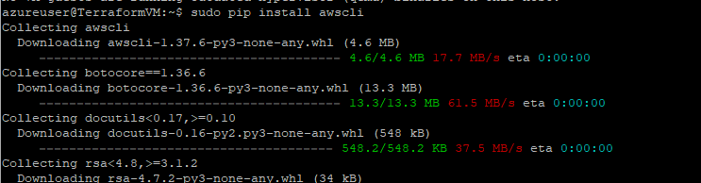
Terraform Installation -
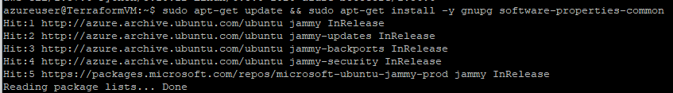
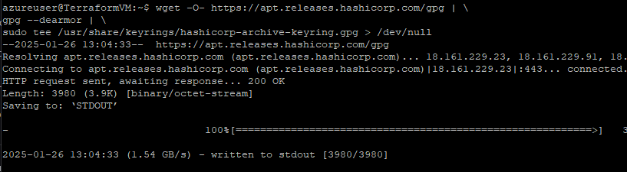
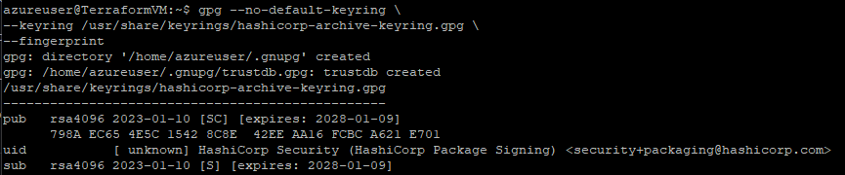
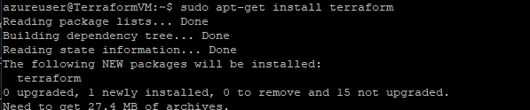
Create Access Key to connect AWS from Terraform
Click on Name at the right top corner -> Click on Security Credentials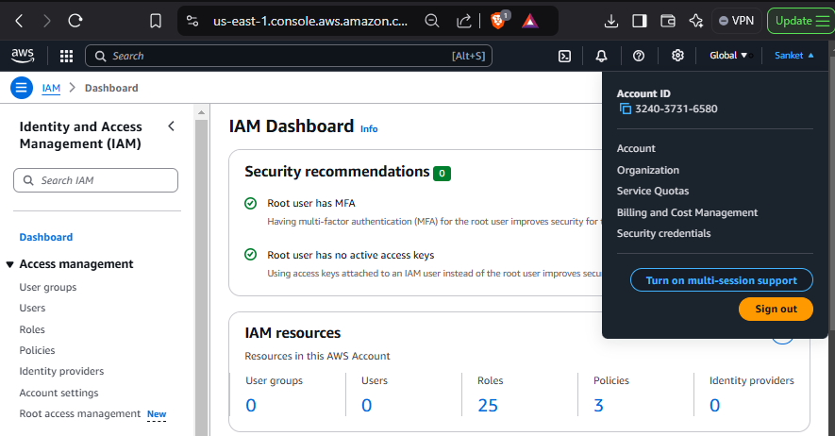
Click on Create Access Key
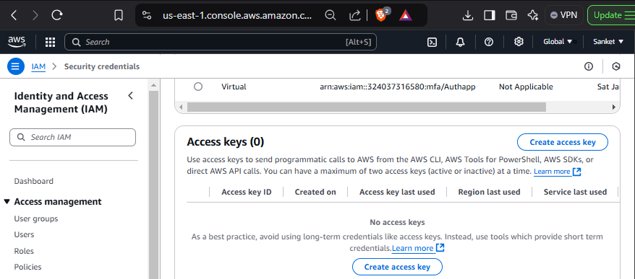
Copy the secret access key
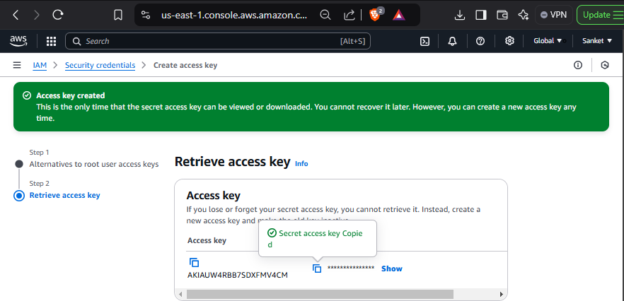
Go to VM again and run aws configure command and enter above copied access key id and secret key and other details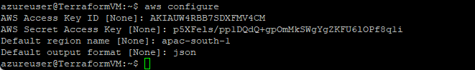
Clone the repository on VM now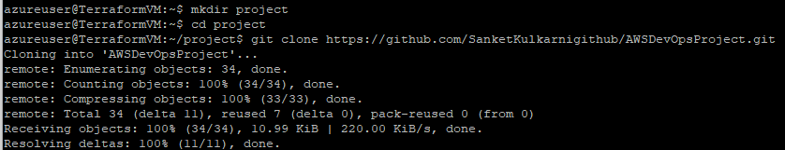
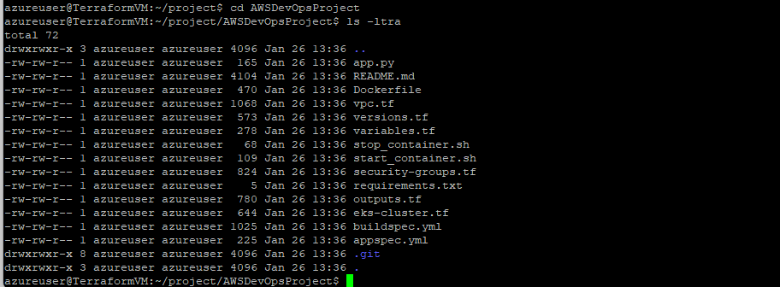
Execute command terraform init
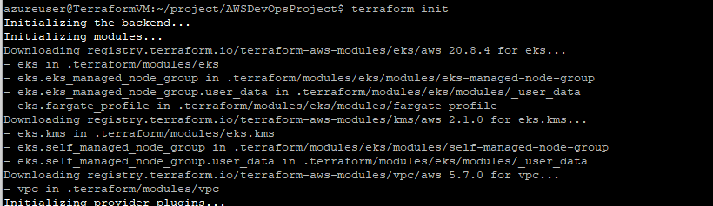
Execute command terraform plan
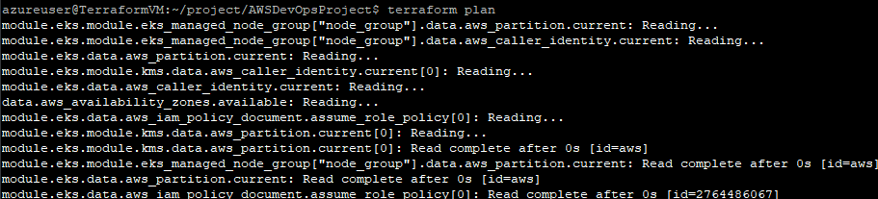
Execute command terraform apply –auto-approve
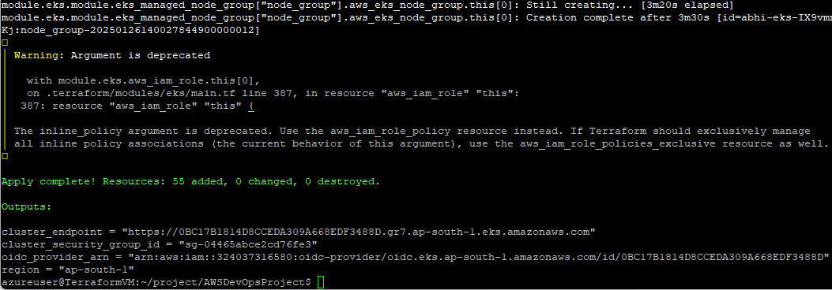
Various Components created through Terraform are reflecting in AWS Portal
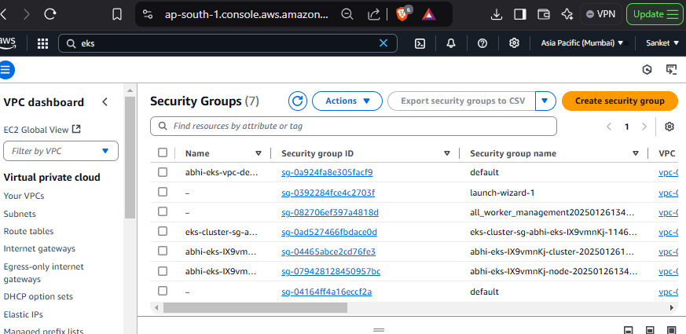

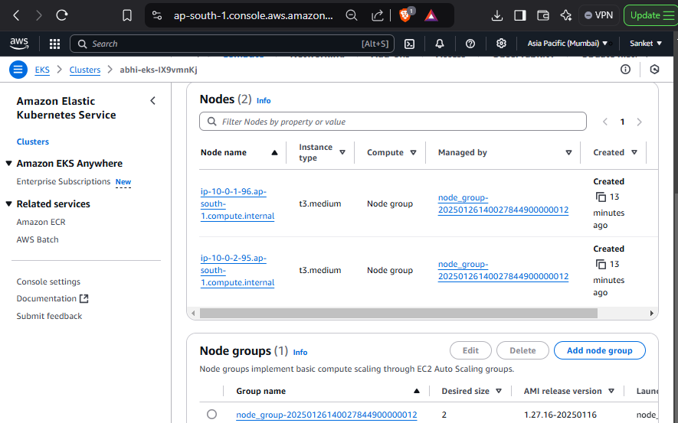

Facing error to go ahead with deployments on AWS EKS

